Dominic Drury

10/01/2024

CS-470

5-2 Assignment: Creating the Database

A screenshot of the overview tab for the Question table or the CSV file of the items from the Question table

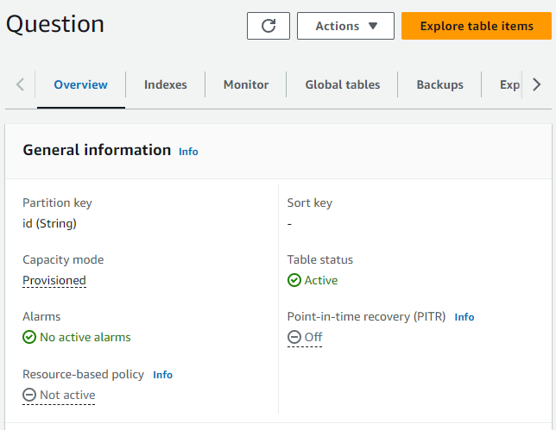

A screenshot of the overview tab for the Answer table or the CSV file of the items from the Answer table

